1. They basically want to get list of the names of customers who had given orders with respect to ascending order of lastname, then ascending order of first name, then descending order of orderdate.
2. Command:

SELECT CustFirstName, CustLastName, OrderDate

FROM Customers c Join Orders o

On o.CustomerID = c.CustomerID

ORDER BY CustLastName, CustFirstName, OrderDate DESC;

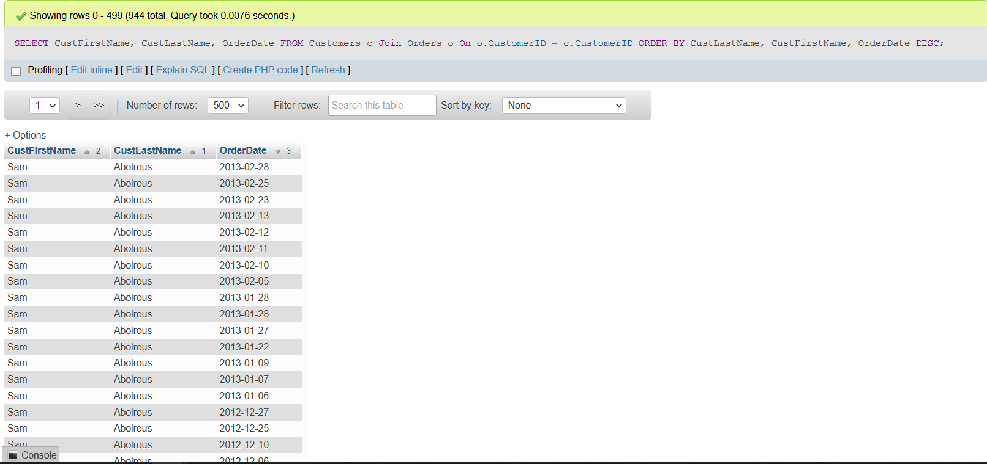

c)

Command:

SELECT CustFirstName, CustLastName, OrderDate

FROM Customers c Left Outer Join Orders o

On o.CustomerID = c.CustomerID

ORDER BY CustLastName, CustFirstName, OrderDate DESC;

(See screenshot on next page)

Screenshot:

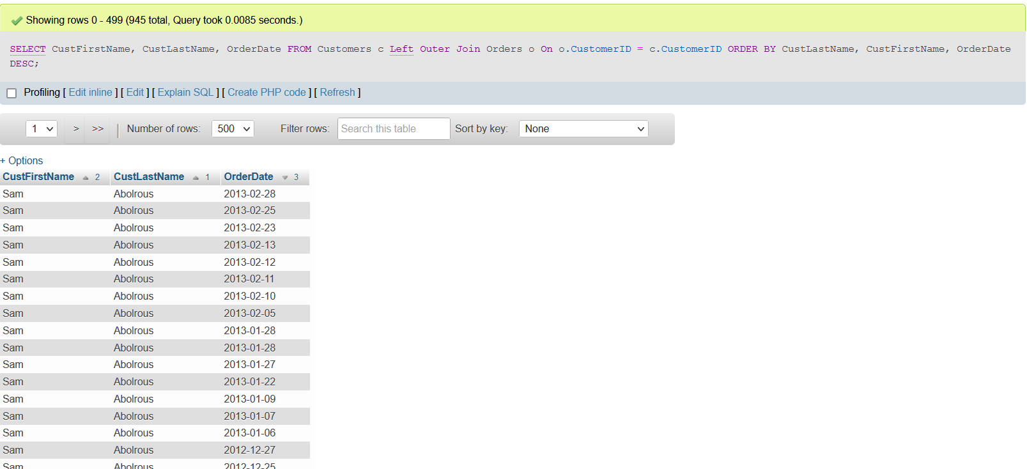

(too many records, so I just scrolled down and took picture of the entry of Jeffrey tirekicker who was the only null one)

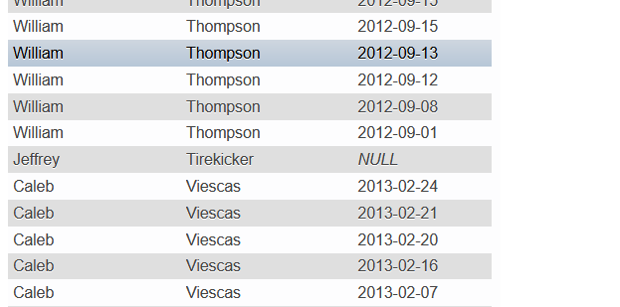

1. Command:

use SalesOrdersExample2;

SELECT c.CustomerID, CustFirstName, CustLastName, OrderDate

FROM Customers c Left Outer JOIN Orders o

ON o.CustomerID=c.CustomerID

where o.OrderDate =

(

select MAX(o.OrderDate)

from orders o

)

ORDER BY CustLastName, CustFirstName, OrderDate desc ;

Had to made another sales order as I had altered the datas in the previous one.

(See screenshot on next page)

Screenshot:

